**Two stroke**

**engine**

**EXPERIMENT # 1**

**DEMONSTRATION OF TWO**

**STROKE ENGINE**

**OR**

**SPARK IGNITION ENGINE**

* 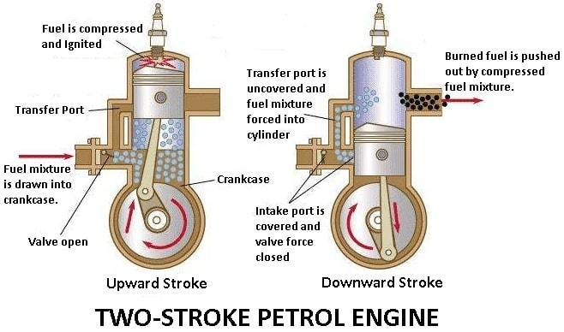**A** Two Stroke Engine is an internal combustion engine which completes the power with two strokes of the piston during only one crankshaft revolution.

**OR**

* A Two Stroke Engine is an Enginein which two strokes are required for one cycle. In two stroke engine there is one revolution per minute
* Actually stroke means distance between top position of piston and bottom position of piston as shown in figure # 2-1:

**PARTS LIST:**

The main parts of Two Stroke Engine are given below in following:

* Carburetor
* Inlet port
* Cylinder
* Piston rings
* Transfer ports
* Connecting rods
* Crankshaft
* Spark plug
* Crank case
* Exit port

**Brief Description Of The Components** :

**Carburetor:**

* A carburetor is a device that mixes air and fuel for internal combustions in the proper air fuel ratio for combustion as shown in Figure # 2-2:

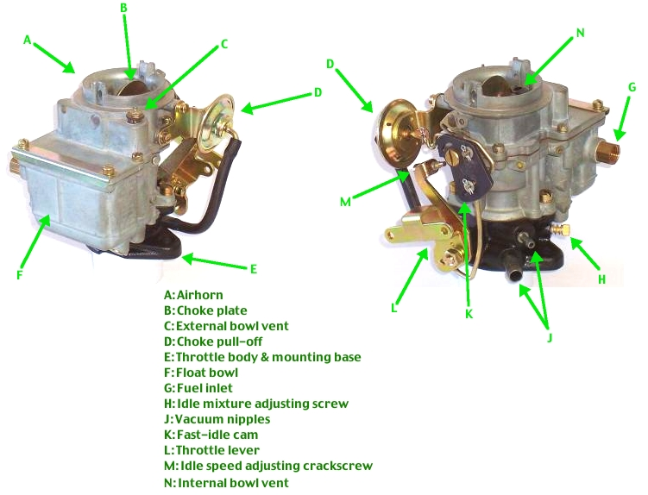**Figure # 2-2:  
Figure # 2-2:**

**Use:**

* It is used to control the speed of vehicles. It converts petrol into fine droplets and mixes it with air in such a way that it burns smoothly in engine.

**Inlet Port: Figure # 2-3:**

* The inlet ports connect to a transfer passage leading to the fully enclosed crankcase. Air trapped in the crankcase is compressed by the decent of the piston on its power stroke as shown

in **Figure # 2-3** 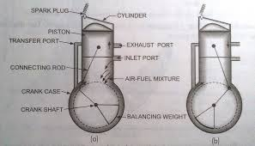

**Use:**

* Intake ports are needed for the air fuel mixture to be properly directed into the combustion chamber for proper combustion.

**Cylinder:**

* In two stroke engine, on the other hand, the crankcase is serving as a pressurization chamber to force fuel air into the chamber
* So, it can’t hold thick oil. Instead you mix oil in with gas to lubricate the crankshaft, connecting rod and cylinder walls as shown in figure # 2-4.

**Figure # 2-4:** 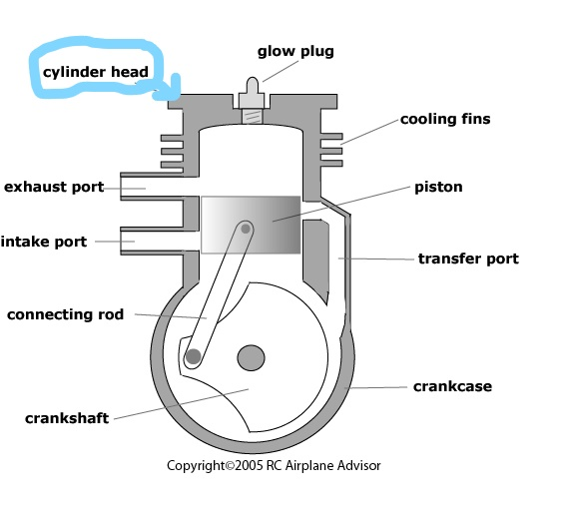

**Use:**

* It not also prevents the air/fuel from travelling into the exhaust port, but also creates a stirring turbulence that enhances combustion efficiency, power and economy

**Piston Rings: figure # 2-5:**

* 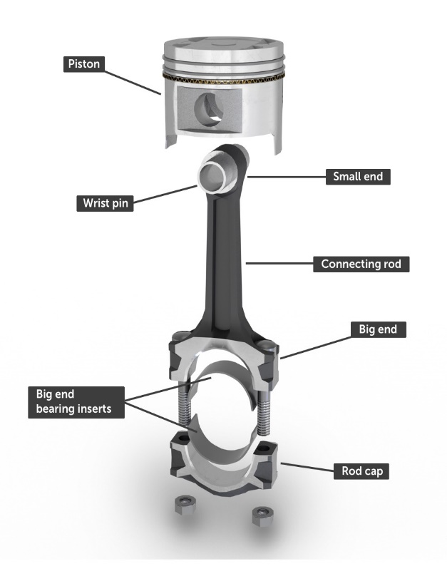Two stroke engines have one or two piston rings. It doesn’t require a scraper ring because it continuously fed by way of premix. In a two stroke air/oil first travels to the crankcase, whether the lower end is then lubricated as shown in figure # 2-5:

**Use:**

* Piston rings are used to seal combustion chamber and wiper rings are installed below them to wipe the deposits from the liner and distribute the oil on the line surface.

**Transfer Port:**

* 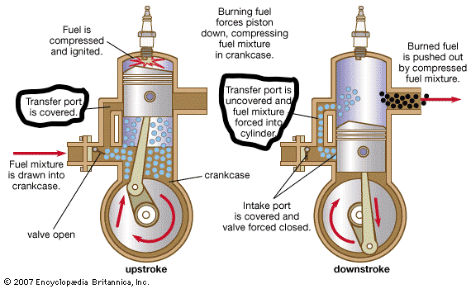It is the passage b/w the cylinder and crankcase. This passage transport fresh air/fuel mixture supplied by the intake from the crankcase to the area of the cylinder currently above the cylinder as shown in figure # 2-6:

**Use:**

* It cools the cylinder. It is also uses in scavenging of the exhaust gases to the outlet.

**Spark plug:**

* It is a device for delivering electric current from an **Figure # 2-7:**

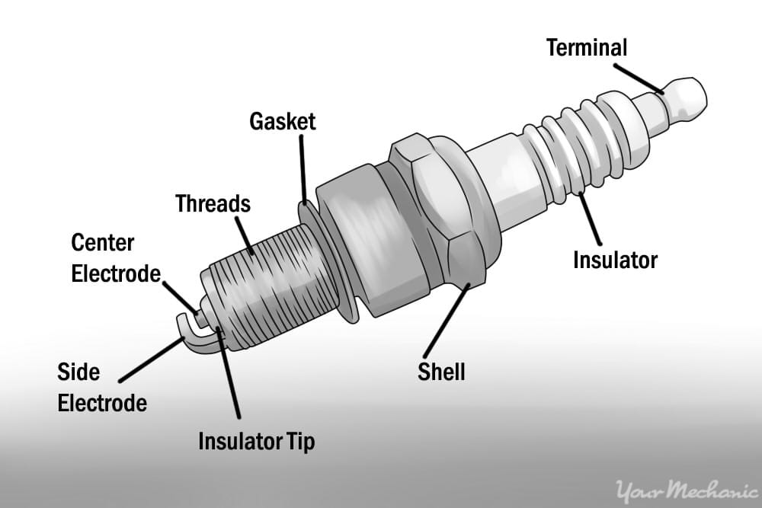 Ignition chamber to of a spark ignition to ignite the mixture of air/fuel by an electric spark, while containing the combustion pressure within the engine

As shown in Figure # 2-7:

**Use:**

* The combustion and reduces the specific combustion automatically will help to increase the efficiency.

**Connecting Rod: Figure # 2-8:**

* 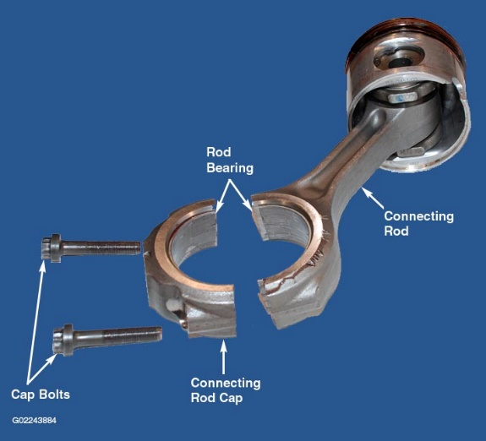A connecting rod is also known as con rod is a part

Of the piston engine which connects the piston to crankshaft. Together with the crank the connecting rods converts the reciprocating motion of the piston into the rotation of the crankshaft as shown in Figure # 2-8:

**Use:**

* It is required to transmit the compressive and tensile forces from the piston and rotate at both ends. It is mostly used in internal combustion engines and steam engines.

**Crankshaft:**

* 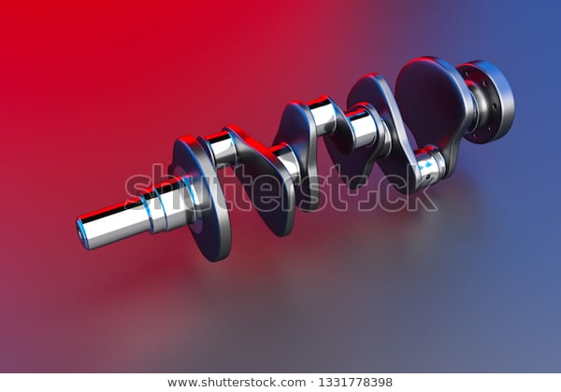A crankshaft is a rotating shaft **Figure # 2-9:**

(In conjunction with the connecting rods) converts the reciprocating motion of the pistons

as shown in figure # 2-9.

**Use:**

* Crankshaft is commonly used in internal combustion engines and consists of series of crank and crank pins to which the connecting rods are attached.

**Crankcase: Figure # 2-10:**

* 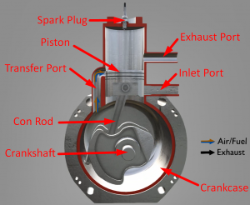 In a two stroke engines crankcase is serving as a pressurization chamber to force air/fuel into the cylinder so it can hold a two stroke engine typically use crankcase compression design, resulting in the fuel/air mixture passing through the crankcase before entering the cylinder as shown in figure # 2-10.

**Exit Port:**

* The exit port is higher and thus is exposed first during the power stroke to allow the exhaust gases to begin flowing out of the cylinder.

**Graph Cycle Explanation:**

**T-S DIAGRAM: P-V DIAGRAM**

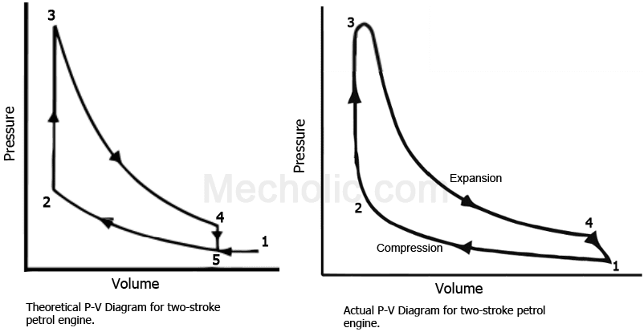

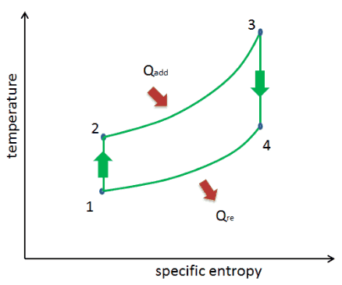

**Lean Mixture and Rich Mixture**

* The key difference between lean and rich mixture is that we use lean mixture for maximum efficiency and we use rich mixture for maximum power in an engine.

Lean mixture has more air than the required quantity of air for complete combustion of fuel .On the other hand, rich mixture has less air than the required quantity of air for complete combustion of fuel in engine.

**Applications:**

* Two stroke engine are preferred when mechanically simplicity, light weight, and high power to weight ratios are traditionally technique of mixing oil into fuel, they also have the advantage of working in any orientation as there is no oil reservoir dependent on gravity ; this is an essential proper power tools such as chainsaws. Therefore it has been used in large diesel engines, mostly large industrial and marine engines, as well as some trucks and heavy machinery.

**PROCESSES**

There are following processes in Two Stroke Engine:

**Intake:**

* During the intake stroke, the fuel air mixture from the carburetor is taken in from the intake valve and the exhaust from the previous cycle is expelled from the exhaust shaft. Actually, exchange of fuel-air mixture with exhaust gases is not perfect .The piston creates an area of flow pressure when it is at the beginning of intake stroke and sucks in air from both intake and exhaust shaft. Hence, exhaust gases are sucked back into the engine for combustion and the fuel-air mixture from the intake shaft are expelled.

**Compression:**

* During the compression stroke, the fuel-air mixture (along with some exhaust gases) is compressed. This is the first half of cycle until the piston reaches its highest point in the cylinder .The next half of the cycle occurs when a spark plug ignites the fuel-air mixture when the piston is at its peak, thereby causing the violent expansion of gases and pushing the piston back down to power the crankshaft and ultimately your vehicle.(This is sometime known as (“Power Stroke”)

**Power** :

* At the top of the stroke, the spark plug ignites the fuel mixture. The burning fuel expands, driving the piston downward, to complete the cycle. (At the same time, another crankcase compression stroke is happening beneath the piston.)

**Exhaust:**

Toward the end of the stroke, the piston exposes the intake port, allowing the compressed fuel/air mixture in the crankcase to escape around the piston into the main cylinder. This expels the exhaust gasses out the exhaust port, usually located on theopposite side of the cylinder. Unfortunately, some of the fresh fuel mixture is usually expelled as well.

**WORKING OF THE CYCLE**

* In a two stroke engine, the end of the combustion stroke and the beginning of the compression stroke happen simultaneously, with the intake and exhaust functions occurring at the same time. Fuel enters from the carburetor and reaches to cylinder for accumulation .There is a transfer port ,from which fuel reaches to the top level of the engine and then there pressure exists, which causes to burn the fuel. Likely, transfer port and inlet port there is a exist port, from which fuel come out.
* Diagram of petrol engine is shown in Figure # 2-11: **Figure # 2-11:**

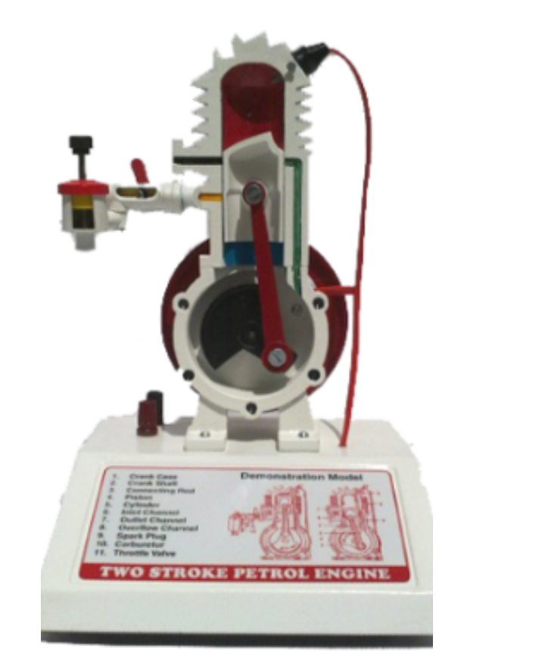

**ADVANTAGES OF TWO STROKE**

**ENGINE**

* Due to the existence of only two strokes, the “Power Stroke” occurs every half cycle .One in every two strokes produces power. This gives the two strokes engines a significantly a higher power-to-weight ratio than four strokes.